1.REACTJS-HOL

Players.js

export const players = [

  { name: "Virat", score: 88 },

  { name: "Rohit", score: 95 },

  { name: "Hardik", score: 65 },

  { name: "Bumrah", score: 45 },

  { name: "Dhoni", score: 55 },

  { name: "Sachin", score: 100 },

  { name: "Rahul", score: 60 },

  { name: "Surya", score: 80 }

];

MergedPlayers.js

import React from "react";

const MergedPlayers = () => {

  const T20Players = [

    { name: "Rishabh" },

    { name: "Shreyas" },

    { name: "Gill" }

  ];

  const RanjiTrophyPlayers = [

    { name: "Prithvi" },

    { name: "Sarfaraz" },

    { name: "Ruturaj" }

  ];

  const merged = [...T20Players, ...RanjiTrophyPlayers];

  return (

    <div>

      <h3>List of Indian Players Merged:</h3>

      <ul>

        {merged.map((player, idx) => (

          <li key={idx}>{player.name}</li>

        ))}

      </ul>

    </div>

  );

};

export default MergedPlayers;

OddEvenPlayers.js

import React from "react";

const OddEvenPlayers = ({ list }) => {

  const odd = list.filter((_, i) => i % 2 !== 0);

  const even = list.filter((_, i) => i % 2 === 0);

  return (

    <div>

      <h3>Odd Players</h3>

      <ul>

        {odd.map((item, idx) => (

          <li key={idx}>{item.name}</li>

        ))}

      </ul>

      <h3>Even Players</h3>

      <ul>

        {even.map((item, idx) => (

          <li key={idx}>{item.name}</li>

        ))}

      </ul>

    </div>

  );

};

export default OddEvenPlayers;

App.js

import React, { useState } from "react";

import { players } from "./data/players";

import OddEvenPlayers from "./components/OddEvenPlayers";

import MergedPlayers from "./components/MergedPlayers";

function App() {

  const [flag, setFlag] = useState(true);

  return (

    <div>

      <button onClick={() => setFlag(!flag)}>Toggle</button>

      {flag ? (

        <div>

          <h3>List of Players:</h3>

          <ul>

            {players.map((item, idx) => (

              <li key={idx}>

                {item.name} - {item.score}

              </li>

            ))}

          </ul>

          <h3>List of Players having Scores Less than 70:</h3>

          <ul>

            {players

              .filter((player) => player.score < 70)

              .map((player, idx) => (

                <li key={idx}>{player.name}</li>

              ))}

          </ul>

        </div>

      ) : (

        <div>

          <h3>Indian Team:</h3>

          <OddEvenPlayers list={players} />

          <MergedPlayers />

        </div>

      )}

    </div>

  );

}

export default App;

index.js

import React from "react";

import ReactDOM from "react-dom/client";

import App from "./App";

const root = ReactDOM.createRoot(document.getElementById("root"));

root.render(

  <React.StrictMode>

    <App />

  </React.StrictMode>

);

OUTPUT:

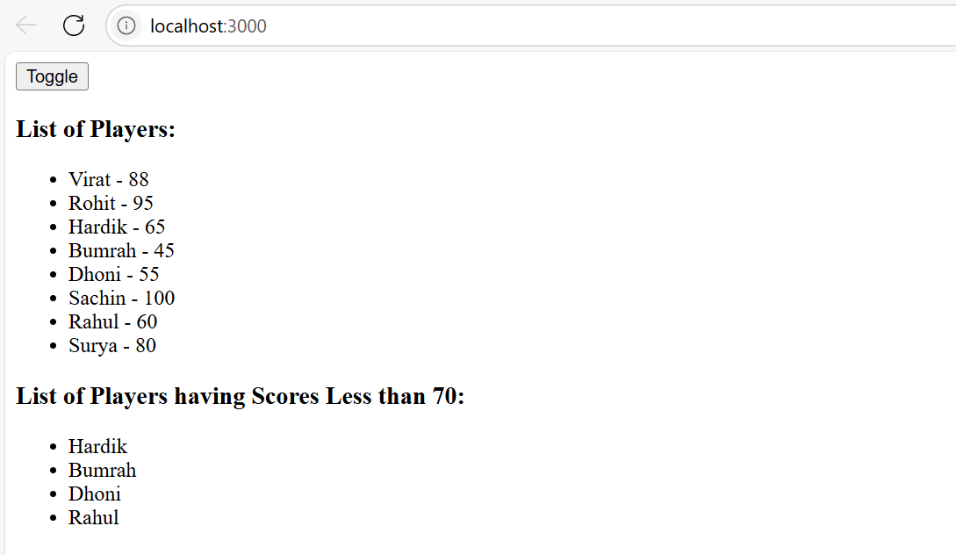

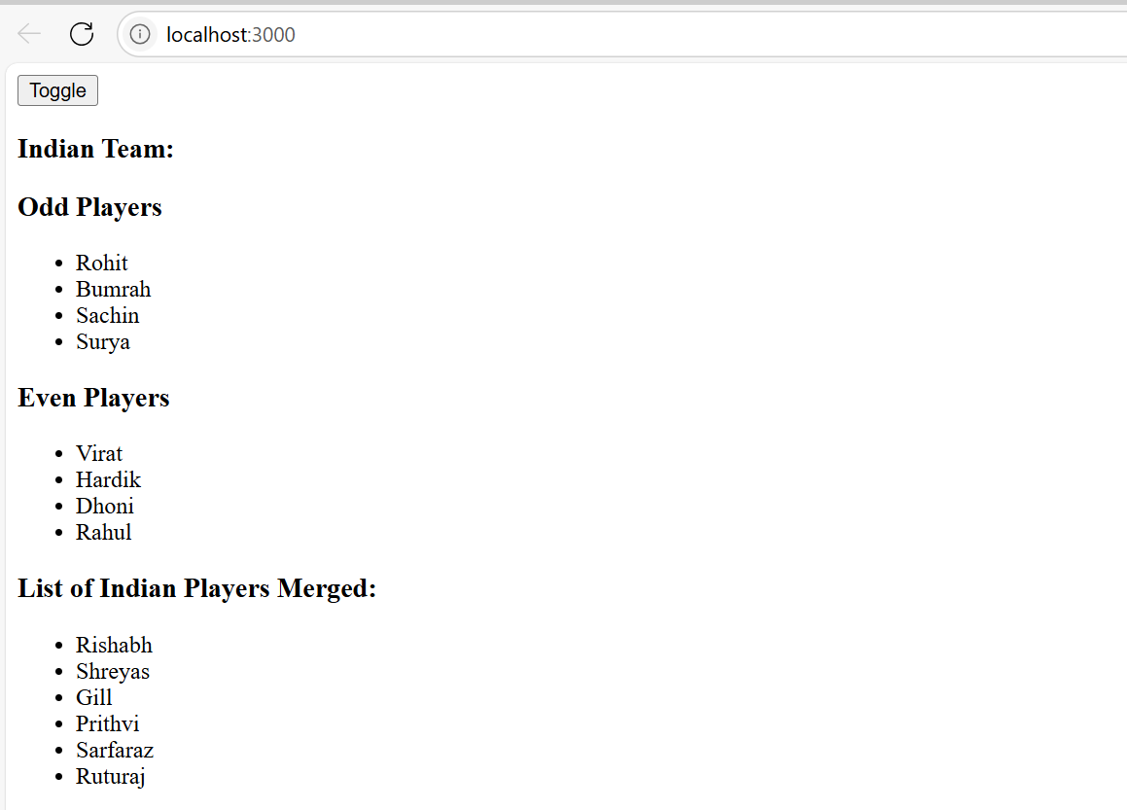

2.

App.js

import React from "react";

const officeSpaces = [

  {

    name: "DBS",

    rent: 58000,

    address: "Chennai",

    image:

      "https://cdn.pixabay.com/photo/2016/11/19/14/00/office-1838660_1280.jpg" // example image

  },

  {

    name: "TCS",

    rent: 75000,

    address: "Bangalore",

    image:

      "https://cdn.pixabay.com/photo/2017/08/06/00/19/office-2583703_1280.jpg"

  },

  {

    name: "Infosys",

    rent: 62000,

    address: "Hyderabad",

    image:

      "https://cdn.pixabay.com/photo/2018/04/13/19/45/business-3315485_1280.jpg"

  }

];

export default function OfficeSpaceApp() {

  return (

    <div style={{ padding: 20 }}>

      <h1>Office Space, at Affordable Range</h1>

      {officeSpaces.map((space, index) => {

        const rentColor = space.rent < 60000 ? "red" : "green";

        return (

          <div

            key={index}

            style={{

              border: "1px solid #ccc",

              marginBottom: 20,

              padding: 10,

              maxWidth: 400,

              borderRadius: 8

            }}

          >

            <img

              src={space.image}

              alt={space.name}

              style={{ width: "100%", height: "auto", borderRadius: 8 }}

            />

            <h2>Office Space: {space.name}</h2>

            <p>

              <b>Name:</b> {space.name}

            </p>

            <p style={{ color: rentColor }}>

              <b>Rent Rs:</b> {space.rent}

            </p>

            <p>

              <b>Address:</b> {space.address}

            </p>

          </div>

        );

      })}

    </div>

  );

}

OUTPUT:

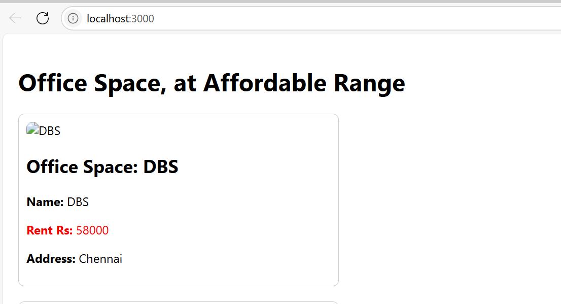

3.

App.js

import React, { useState } from "react";

function App() {

  const [count, setCount] = useState(0);

  const [amount, setAmount] = useState("");

  const [currency, setCurrency] = useState("INR");

  const [convertedAmount, setConvertedAmount] = useState(null);

  const increment = () => setCount(count + 1);

  const decrement = () => setCount(count - 1);

  const sayHello = () => alert("Hello");

  const sayWelcome = (name) => alert(`Welcome ${name}`);

  const handleOnPress = (e) => alert("I was clicked!");

  const handleSubmit = (e) => {

    e.preventDefault();

    if (currency === "INR") {

      const euro = Number(amount) * 0.012; // 1 INR = 0.012 Euro approx

      setConvertedAmount(euro.toFixed(2));

    } else {

      setConvertedAmount(null);

    }

  };

  return (

    <div style={{ padding: 20 }}>

      <h2>Currency Convertor!!!</h2>

      <div>

        <h3>Counter: {count}</h3>

        <button onClick={increment}>Increment</button>{" "}

        <button onClick={decrement}>Decrement</button>

        <p>Hello</p>

      </div>

      <hr />

      <div>

        <button onClick={() => sayWelcome("User")}>Say Welcome</button>

      </div>

      <hr />

      <div>

        <button onClick={handleOnPress}>Click Me (Synthetic Event)</button>

      </div>

      <hr />

      <CurrencyConverter

        amount={amount}

        setAmount={setAmount}

        currency={currency}

        setCurrency={setCurrency}

        handleSubmit={handleSubmit}

        convertedAmount={convertedAmount}

      />

    </div>

  );

}

function CurrencyConverter({

  amount,

  setAmount,

  currency,

  setCurrency,

  handleSubmit,

  convertedAmount

}) {

  return (

    <form onSubmit={handleSubmit}>

      <label>

        Amount:

        <input

          type="number"

          value={amount}

          onChange={(e) => setAmount(e.target.value)}

          required

          style={{ marginLeft: 10 }}

        />

      </label>

      <br />

      <label>

        Currency:

        <select

          value={currency}

          onChange={(e) => setCurrency(e.target.value)}

          style={{ marginLeft: 10 }}

        >

          <option value="INR">INR</option>

          <option value="EUR">Euro</option>

        </select>

      </label>

      <br />

      <button type="submit">Convert</button>

      {convertedAmount !== null && (

        <p>

          Converted Amount in Euro: <b>{convertedAmount}</b>

        </p>

      )}

    </form>

  );

}

export default App;

OUTPUT:

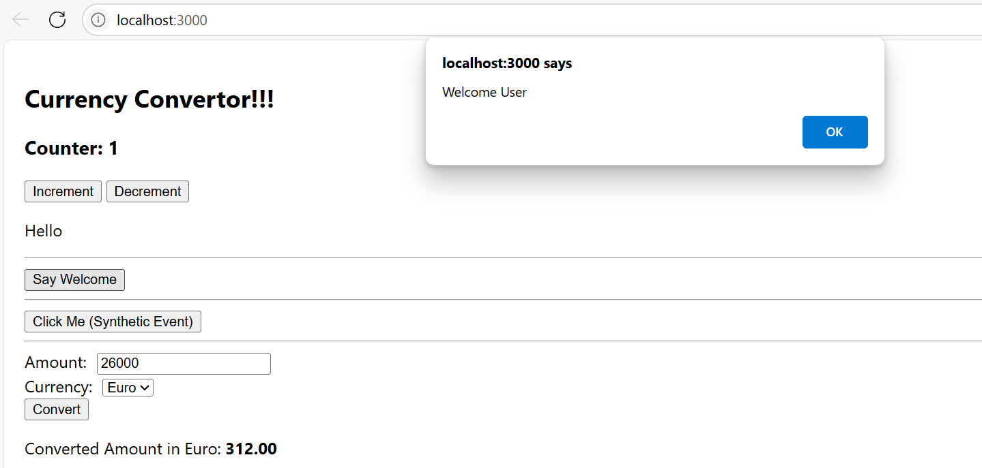

4.

App.js

import React, { useState } from "react";

function LoginButton(props) {

  return <button onClick={props.onClick}>Login</button>;

}

function LogoutButton(props) {

  return <button onClick={props.onClick}>Logout</button>;

}

function Greeting(props) {

  const isLoggedIn = props.isLoggedIn;

  if (isLoggedIn) {

    return <UserGreeting />;

  }

  return <GuestGreeting />;

}

function UserGreeting() {

  return <h2>Welcome back</h2>;

}

function GuestGreeting() {

  return <h2>Please sign up.</h2>;

}

function TicketBookingApp() {

  const [isLoggedIn, setIsLoggedIn] = useState(false);

  const handleLoginClick = () => setIsLoggedIn(true);

  const handleLogoutClick = () => setIsLoggedIn(false);

  return (

    <div style={{ padding: 20 }}>

      <Greeting isLoggedIn={isLoggedIn} />

      {isLoggedIn ? (

        <LogoutButton onClick={handleLogoutClick} />

      ) : (

        <LoginButton onClick={handleLoginClick} />

      )}

    </div>

  );

}

export default TicketBookingApp;

OUTPUT:

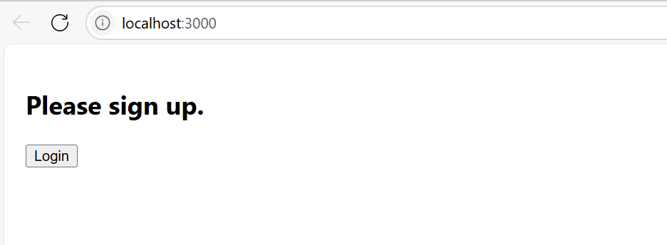

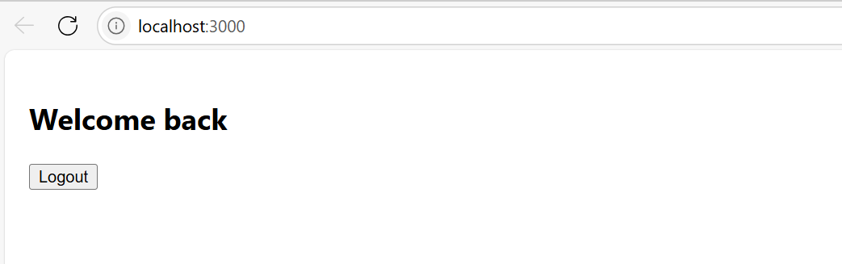

5.

import React from "react";

const bookdet = [

  { id: 101, name: "Master React", price: 750 },

  { id: 102, name: "Deep Dive Into Angular 11", price: 800 },

  { id: 103, name: "Mongo Essentials", price: 450 },

];

function CourseBookBlog() {

  const courseDet = [

    { name: "Angular", price: 4500 },

    { name: "React", price: 5500 },

  ];

  const blogDet = [

    { title: "React Learning", description: "Beginner Kit" },

    { title: "Installation", description: "You can install React from npm" },

  ];

  return (

    <div style={{ display: "flex", justifyContent: "space-around", padding: 20 }}>

      <div className="course" style={{ flex: 1 }}>

        <h3>Course Details</h3>

        <ul>

          {courseDet.map((course) => (

            <li key={course.name}>

              {course.name} - Rs. {course.price}

            </li>

          ))}

        </ul>

      </div>

      <div className="book" style={{ flex: 1, borderLeft: "1px solid green", paddingLeft: 20 }}>

        <h3>Book Details</h3>

        {bookdet.map((book) => (

          <div key={book.id}>

            <h4>{book.name}</h4>

            <p>Rs. {book.price}</p>

          </div>

        ))}

      </div>

      <div className="blog" style={{ flex: 1, borderLeft: "1px solid green", paddingLeft: 20 }}>

        <h3>Blog Details</h3>

        {blogDet.map((blog, index) => (

          <div key={index}>

            <h4>{blog.title}</h4>

            <p>{blog.description}</p>

          </div>

        ))}

      </div>

    </div>

  );

}

export default CourseBookBlog;

OUTPUT:

